Worksheet - Crypto Market Structure and a Self-Custody Wallet Lab
Week 3, Session 1 | Assessment 2 (A2) - the weekly worksheets | You submit this yourself
Complete it in class and submit it on Moodle before you leave.
Your details (not marked)
Full name | Meqdad Muhana
Student ID | 202306213
Today's partner / group | Ali Mohammed Radhi - 202304871
How this worksheet works
• This worksheet counts towards Assessment 2. You complete and submit it yourself, even when you work with others.
• Write your answers in your own words, and list any sources you used in Task 4.
Words to know
These are the words this worksheet uses. You are not marked on the definitions themselves, only on using the ideas.
Term | Plain meaning
Transaction | One instruction to move value from one holder to another, and the record of that move.
Wallet | The app or device that stores the secret codes which control what you own on a blockchain. It does not hold the assets themselves. Those stay on the record book.
Block explorer | A free public website that lets anyone look up any transaction or any block on a public blockchain.
Coin | A token that belongs to a blockchain's own record book and is used to pay that network's fees. Bitcoin and ether are coins.
Custody | Who holds the secret keys, and so who actually controls the assets. Either you hold them yourself, or a licensed firm holds them for you.
Operational risk | The risk of losing money because of how the business is run. That covers a mistake, a process that fails, a system that goes down, or a person acting dishonestly.
Failure mode | The specific way a thing can go wrong, named precisely, rather than a general worry.
Testnet | A practice copy of a blockchain that uses worthless test coins, so you can try things without risking real money.
Mainnet | The real, live blockchain, where the coins have real value.
Faucet | A website that hands out free testnet coins, so you can practise without spending anything. The coins it gives out have no value.
Tools you need today
Every tool below is free and none of them needs real money. If one will not work, read its last line and carry on. A tool that refuses you is not your mistake.
MetaMask, a self-custody wallet
• Where to find it - MetaMask download: https://metamask.io/download
How to get to what you need:
1. Install the browser extension from the address above, before class.
2. Open it, choose Create a new wallet, then choose the Secret Recovery Phrase option. Do NOT choose the Google, Apple or Telegram option: it gives you no phrase, and securing the phrase is what this session is about.
3. Set a password you have never used anywhere else.
4. Write the twelve English words on paper, in order. Never type them into any website, and never photograph them.
5. Turn test networks on: open the menu at the top right, choose Networks, then switch on Show test networks at the bottom of the list.
6. Now switch the network to Sepolia. Check it says Sepolia before going on.
Before you start:
• Install it before the Week 3 session. It is free.
• Only ever install from the address above. Copies of this extension exist that steal recovery phrases.
• Sepolia does not appear in the network list until you turn test networks on.
If it does not work: If the extension will not install on a campus machine, ask the lecturer for a pre-funded practice wallet. The rest of the lab runs the same way.
A Sepolia faucet, which hands out free practice coins
• Where to find it - Google Cloud Sepolia faucet: https://cloud.google.com/application/web3/faucet/ethereum/sepolia
How to get to what you need:
1. Copy your wallet address: open MetaMask and click the account name at the top. The address copies itself, and a tick appears to say so.
2. Open the address above and sign in with a Google account.
3. Paste your wallet address and request the practice coins.
4. They usually arrive in under a minute. Check the balance in MetaMask.
Before you start:
• Your wallet must already be switched to Sepolia.
• A faucet counts requests per internet connection, so on the campus network it will refuse some students. That is normal and it is not your mistake.
If it does not work: If the faucet refuses you, tell the lecturer. Pre-funded practice wallets are held ready for exactly this, and you import one and carry on.
Sepolia Etherscan, the practice-network explorer
• Where to find it - Sepolia Etherscan: https://sepolia.etherscan.io
How to get to what you need:
1. Open the address above. THIS IS A DIFFERENT SITE from etherscan.io.
2. Find your transaction hash: in MetaMask, open the Activity tab, click the transaction, then click the copy icon beside Transaction ID. A block explorer calls that same code the transaction hash.
3. Paste it into the search box on this site and press Enter.
4. Your transaction page opens. Screenshot it for your worksheet.
Before you start:
• A practice-network transaction NEVER appears on etherscan.io. That site holds the real network only. Searching there finds nothing, and the transfer is fine.
If it does not work: If your transaction does not appear, wait thirty seconds and search again. If it still does not, show the lecturer the hash from your wallet.
Taking the screenshot
• On Windows, hold the Windows key, Shift and S together, then drag a box around what you want to capture.
• On a Mac, hold Command, Shift and 4 together, then drag the box.
• Your student ID has to be readable in the picture. Open a blank note beside the browser window, type your ID into it, and include that note inside the box you drag.
• Paste the picture straight into this worksheet, under the task it belongs to. Do not send it as a separate file.
Task 1 - From the reading
Answer the guiding questions from the structured extract.
Expected: 2-3 sentences per question.
Q1. Why is 'not your keys, not your coins' true?
A wallet houses the private keys that mathematically permit the movement of funds, rather than holding the actual coins themselves. When a third party retains these keys, they assume absolute technical control over your assets, meaning you must completely rely on their institutional integrity not to misplace or embezzle your funds. Under the Central Bank of Bahrain (CBB) Crypto-asset Module (CRA), managing client keys legally categorizes a provider as a custodian, demanding strict regulatory safeguarding rules precisely because the client lacks direct cryptographic control.
Q2. Rank custodial, hot self-custody and cold multi-sig by operational risk, and say why.
Cold multi-sig presents the lowest operational risk because keys are generated and held entirely offline across several independent hardware devices, systematically removing single points of cyber or physical failure. Hot self-custody presents medium operational risk; although the individual holds sole key ownership, the primary device's constant internet connection makes it highly vulnerable to malware or phishing attacks. Custodial setups pose the highest operational risk because the individual relinquishes key control entirely to a centralized third party, exposing the assets to corporate bankruptcy, internal staff fraud, or regulatory freezes.
Q3. What is the one failure that has no recovery, and how do you defend against it?
The single failure mode without any technical recovery is the permanent misplacement or destruction of the mnemonic seed phrase, because a decentralized blockchain possesses no central administrator or support desk to restore access. Protecting against this entails etching the seed phrase onto fireproof metal plates kept in geographically distributed, access-controlled physical vaults instead of depending on vulnerable paper or digital storage. Furthermore, institutions defend against this by enacting multi-signature governance frameworks so that the forfeiture of a single key does not permanently lock the underlying treasury funds.
Task 2 - Apply it (individual build task)
Now use the ideas from Task 1 to do this, in your own words:
Classify these three wallet arrangements by operational risk, naming the risk class and the main failure you are exposed to in each: (1) an account at an overseas exchange; (2) MetaMask on your laptop; (3) a hardware wallet with 2-of-3 multi-sig, which means two of the three key holders must both approve before any funds can move.
Expected: one or two lines per arrangement (three in total).
(1) An account at an overseas exchange:
This constitutes a Custodial setup where a foreign third-party corporation holds the private keys, generating direct counterparty risk because you possess no cryptographic control over the ledger. The main failure mode is complete asset loss if the exchange experiences insolvency, commingles client funds, or suffers a centralized server breach.
(2) MetaMask on your laptop:
This forms a Hot Self-Custody setup where you individually hold your own private key on an internet-connected computer, producing high cyber risk due to continuous network exposure. The primary failure mode is unapproved key extraction and total loss of funds via malware or credential theft through misleading phishing websites.
(3) A hardware wallet with 2-of-3 multi-sig:
This forms a Cold Multi-Signature setup where several assigned organizational signers keep separated keys offline on hardware modules, drastically reducing remote cyber risk. Because the risk moves from the network to the physical world, the main failure mode becomes physical governance breakdowns, namely the concurrent destruction of several backup devices or unlawful collusion between two key holders to outvote the third.
Task 3 - Group activity (your own write-up)
Self-custody wallet lab (testnet only).
Set up a Sepolia testnet wallet, secure the mnemonic, send and read back a test transaction. Testnet only - never mainnet funds.
• Follow the lab sheet, IT8204 Week3 S1 LabSheet v1.docx, in this session's Moodle section. It gives the eight steps in order, and what to do when one fails.
• Create a self-custody wallet and record how you secured the seed phrase.
• Get Sepolia testnet ether (ETH) from a faucet and send a small test transaction.
• Read the transaction back on Sepolia Etherscan, the practice-network explorer, which is a separate site of its own, and screenshot it with your student ID visible.
• Write one line interpreting the transaction for a non-technical audience.
Expected: complete the activity above, then write your own answer of about half a page.
Write your own answer here:
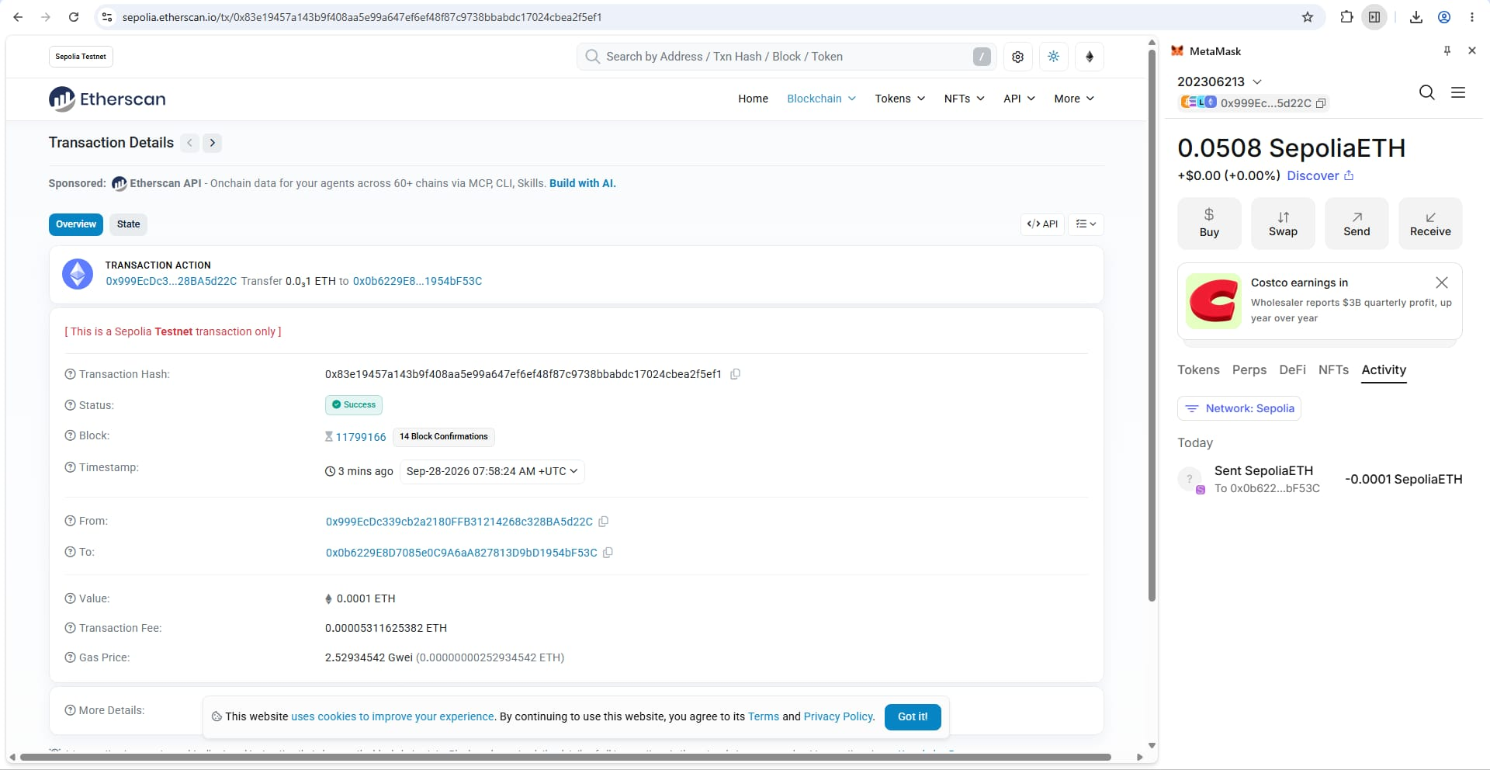
To execute this self-custody lab, I first created a new MetaMask wallet on the Sepolia testnet. I secured the 12-word mnemonic seed phrase by writing it physically on a piece of paper, a method that prevents remote cyber extraction, though its primary weakness is its physical vulnerability to fire or loss. After obtaining practice funds from the Google Cloud Sepolia faucet, I initiated a transaction by broadcasting my signed intent from my wallet to the network's mempool. Following the feedback from last week's assessment, I have attached a screenshot of Sepolia Etherscan with my Student ID (202306213) visible in the top right corner to serve as the immutable public record of this specific event.
Non-technical interpretation:
This explorer record proves that on September 28, 2026, the sender (my wallet ending in d22C) successfully transferred exactly 0.0001 practice ETH to a recipient (ending in F53C) which was permanently recorded in block 11799166, paying a small network fee of 0.000053 ETH to execute the transfer.
Task 4 - Sources
Sources I used (if any) | Sepolia Etherscan Transaction Record:  https://sepolia.etherscan.io/tx/0x83e19457a143b9f408aa5e99a647ef6ef48f87c9738bbabdc17024cbea2f5ef1  Central Bank of Bahrain. (2019). Crypto-asset Module (CRA), Chapter CRA-8 (Custody of Crypto-Assets).  Drescher, D. (2026). Blockchain basics (2nd ed.), Steps 14-18. Apress / Springer Nature.  Bahrain Polytechnic. (2026). IT8204 Week 3 Session 1: Structured Extract, Visual Reading, and Lab Sheet v1.  MetaMask (Self-custody wallet browser extension).  Google Cloud Web3 Faucet (Sepolia testnet practice coins).
Before you submit
• Your name and student ID are filled in.
• All tasks are attempted.
• Submit this sheet before you leave today, to the Week 3 weekly worksheets link on Moodle. That same link takes both of the Week 3 weekly worksheets, one per session.
• If you need more time, finish it at home and submit to the same link by Friday 2 October 2026, 23:59. That is the deadline for both Week 3 sheets.
• Both weekly worksheets are marked together in one Week 3 marking sheet worth 2.50 percent of the course.
• You may use your notes and the session readings. Every worksheet is your own work.

